**MOVE PORT**

*** PLEASE DO NOT MOVE ANY ETHERNET PORTS WITHOUT CONSULTING WITH TIER3 ***

Sample Ticket : 000000267662056

|  |
| --- |
| Note added by rc9141 on:  09/02/2019 19:11:38 ET for Ticket #: 000000267662056 |
| Application: INSTAR  Problem: MOVE PORT  CURRENT_CUSTOMER_ID: 920051  NEW_CUSTOMER_ID: 1122830  PREMISE_ID: 3602634  NEW_PREMISE_ID: 3810115  SITE_ID: 13769090  PORT_ID: 11934434  CURRENT_DOMAIN: na9250051.com  NEW_DOMAIN: na1122830.com  RPT_SVC_LINE: MIS  RPT_SUB_SVC_LINE: MIS EaMIS  SERVICE_IMPACT: No  KEY_ITEM_AFFECTED: 1  CNTRL_INTRO: No  BULK_MOVE_FILE: None  MORE_INFO:  REF_TKT_NUM:  SUBMITTER_ATTUID: rc9141  - Client Email: rc9141@att.com |

1. The following information needs to be present in the ticket to proceed; please do not accept the information via email or Q – all information must be within the ticket
   1. Current Customer ID
   2. New Customer ID
   3. Current Premise ID
   4. New Premise ID
   5. Site ID
   6. Port ID
2. Research to ensure the ACCESS TYPE (Ethernet vs Non-Ethernet)
   1. Using the Port ID, search on the **SITE** dropdown

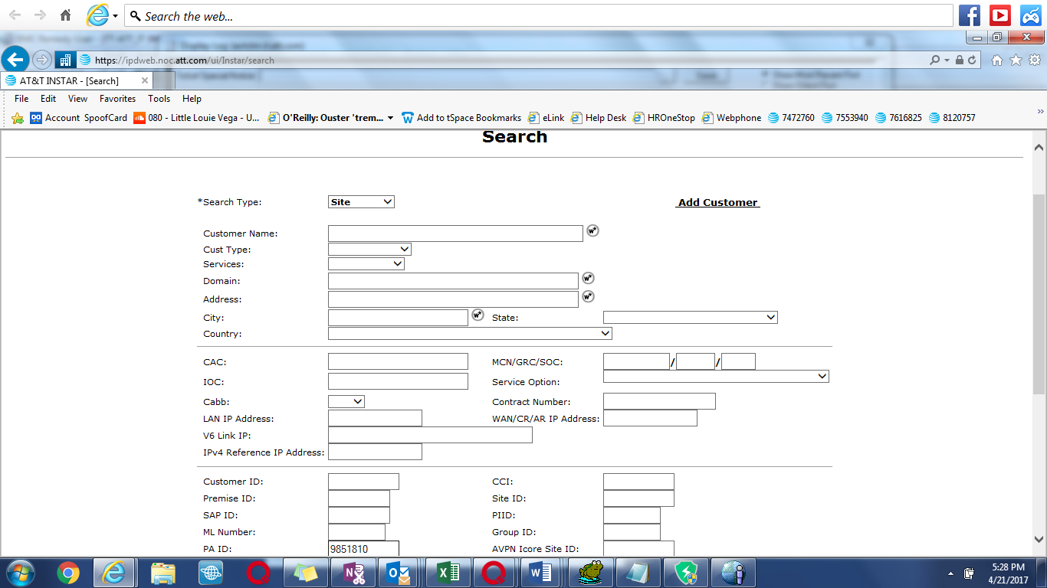

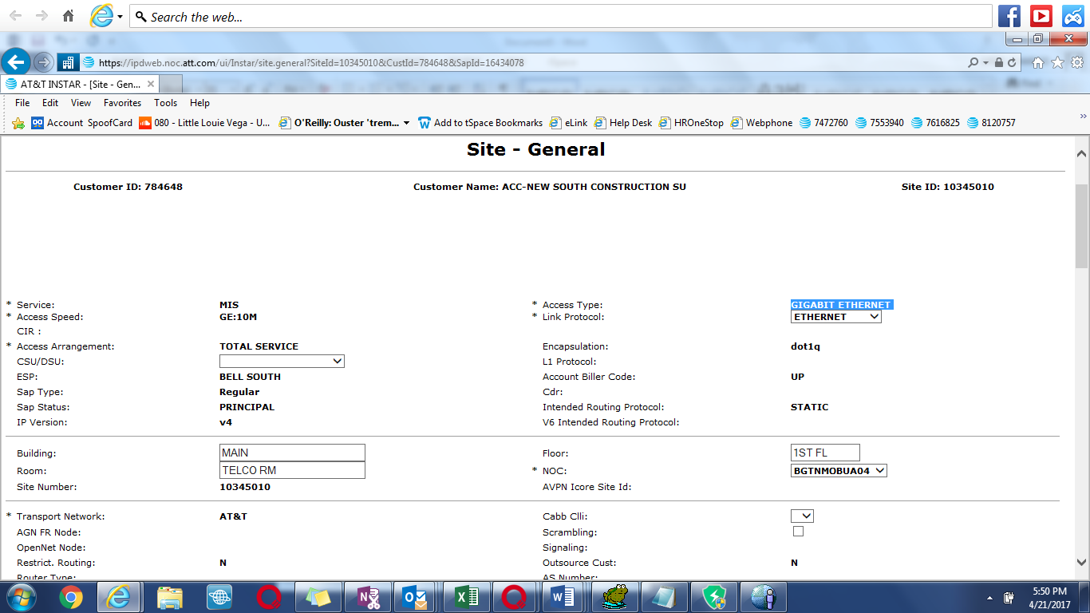

1. Seeing that this is GIGABIT ETHERNET – please consult TIER3 prior to MOVING by sending an EMAIL explaining who is requesting the MOVE (user id from the ticket) and if this is a Single or part of a Group (check the db )
   1. Ex: Tier3, Russ Caluri is requesting to move the following Single Link Gigabit Ethernet Port ID: 9851810. Please let me know if/when to proceed
      1. Once Tier3 gives permission to complete the move, proceed to step 4
2. From LPP Home Page, Go to Tools 🡪 Tier III 🡪 “Premise/Site Move Tool” link

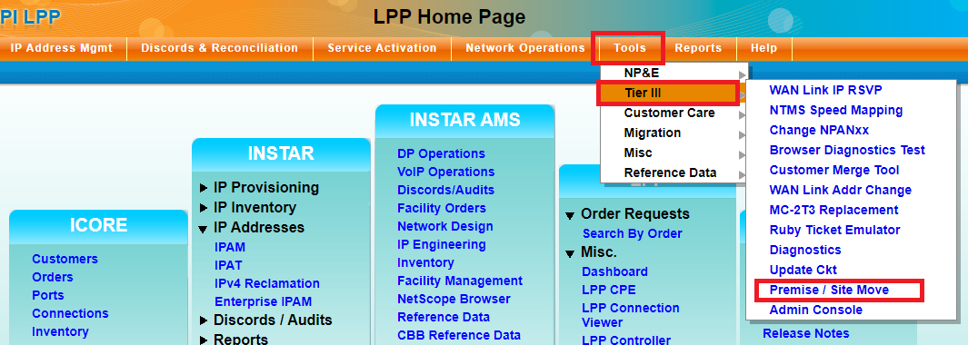

1. This will bring you to the move page where the information is going to be inserted. At the top of the page is the dropdown for the “Action” field. Please change this to **SiteMoveOnly**
2. Proceed by inputting all of the following:
   1. Source Customer ID: <Current Customer ID>
   2. Target Customer ID: <New Customer ID>
   3. Source Location ID: <Current Premise ID>
   4. Target Location ID: <New Premise ID?
   5. Source Site ID: <Site ID>
   6. Source Port Assignment ID: <Port ID>
3. Once all of the information has been entered, click OK.

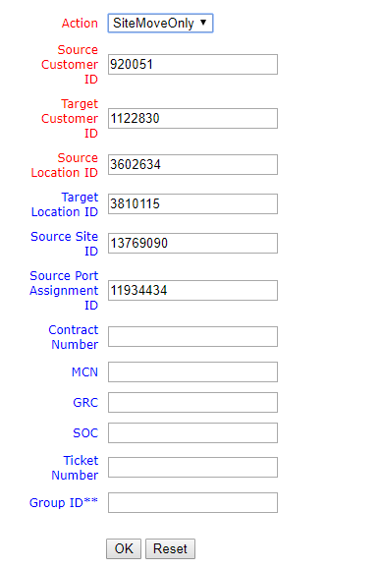

1. Click “YES” to Confirm.

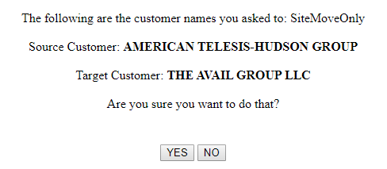

1. You should get a successful or failure message within 10 second.
   1. Success – Copy the success message into the ticket
   2. Failure – Copy the error message into the ticket and open an IE ticket to TIER3 for investigation